**Features**

**According to a recent survey conducted by stack overflow. JavaScript is the most popular language on earth.**

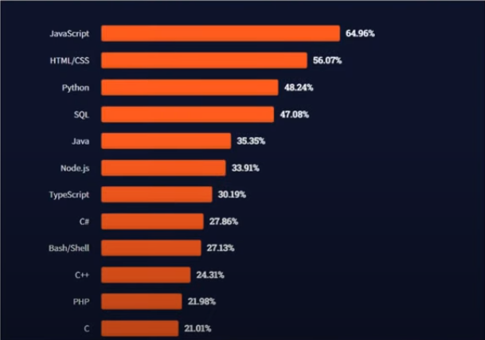

**With advance in browser technology and js having moved into server with node.js and other frameworks, js is capable of so much more. Here are a few things that we can do with JavaScript :**

* **JavaScript was first place for DOM manipulation. Earlier website were mostly static, after JS was created dynamic websites were made.**
* **Function in JS are objects. They have many properties and method just like another object. They can be passed as argument in other functions.**
* **Can handle date and time.**
* **Perform form validation although the forms are created using HTML**
* **No compiler is needed.**